|  |
| --- |
| Ravash inc. |
| Space Master 9000!! |
| **Project 1A** |
| Version #1.0  All work Copyright © 2012 by Ravash inc.  All rights reserved. |
| **Dylan Scott** |
|  |



|  |
| --- |
| August 8th, 2012 |

**Table of Contents**

1. Version History
2. Detailed Application Description
3. Controls
4. Interface Sketch
5. Screen Shots
6. Game World
7. Levels
8. Characters / Vehicles
9. Enemies
10. Weapons
11. Scoring
12. Sound Index
13. Art / Multimedia Index

# 

# Version History

* 1. - For this game I decided to start using MailPilot.py as my template for my game because it is a very good place to start and I wasn't a huge fan of my rushed Assignment 4. The sprite's used for my game I acquired from http://spriters-resource.com/ with the background being custom made by me. In this version I have taken out majority of the code that is attributed to the classes of MailPilot and rewrote it for classes in my game. So far my game has one difficulty ( which I plan on working on soon ) and the main player doesn't have the ability to shoot ( Also I plan on making the enemies have a chance of shooting, maybe increased chance depending on difficulty?) The current version the points are based 100% of collecting either award of the two awards ( I plan on maybe making it that each difficulty has different number of awards on the screen, Easy have 3, normal having 2 and hard having only one award the player can collect)
  2. - In this version I have changed it so if enemy ships hit either the left or right side of the screen, they will bounce back into play. In this version I have added the bullet class that allows the spaceship to shoot 1 shot into the enemies. I have added difficulties to the game that increase the number of enemies by a base amount ( easy has 4, normal has 8, hard has 12) and also reducing the number of award pickups on the screen ( easy has 3, normal has 2 and hard has 1).

0.3 - In my game I set the bullet1 to only be able to fire one at a time. In later versions of the game I plan on adding bullets depending on your difficulty. I have changed over all the sounds to what I want to be in the game and played and adjusted all the volumes of the sound. I've changed up the speeds of the aliens to give each alien type its own little bit of style and adjust game play a little bit.

0.4 - This this version I am going to up the number of bullets the player can use to 3 on each difficulty. I have changed the introduction screen to explain the instructions for my game. I've added the game over screen that takes the score of the player during his last session. I didn’t feel there was enough enemies to make it challenging so I added 4 more to each difficulty.

1.0 - In this version I will an additional bullet to the hard difficulty and take away one bullet on the easy to adjust balance between the difficulties.

* 1. In this version I plan on adding an increased tier of difficulty. The newest difficulty gives the player 1 extra bullet, increases the points awarded for collecting awards 600 and adds 8 more enemies.

# Detailed Application Description:

My program is a top scrolling space adventure game. You are a lone pilot against hordes and hordes of enemies that never seem to stop. Your objective is to collect as much score and surviving as long as possible. Depending on the difficulty you choose, you have varying ammunition limits and enemies on the field at each time.

# Controls:

The spaceship you pilot is controlled by the mouse. If you wish to fire you would use the left-click on the mouse. On the instructions screen, Click 1 for easy difficulty, 2 for normal difficulty, 3 for hard difficulty and 4 for master difficulty.

# Interface Sketch:

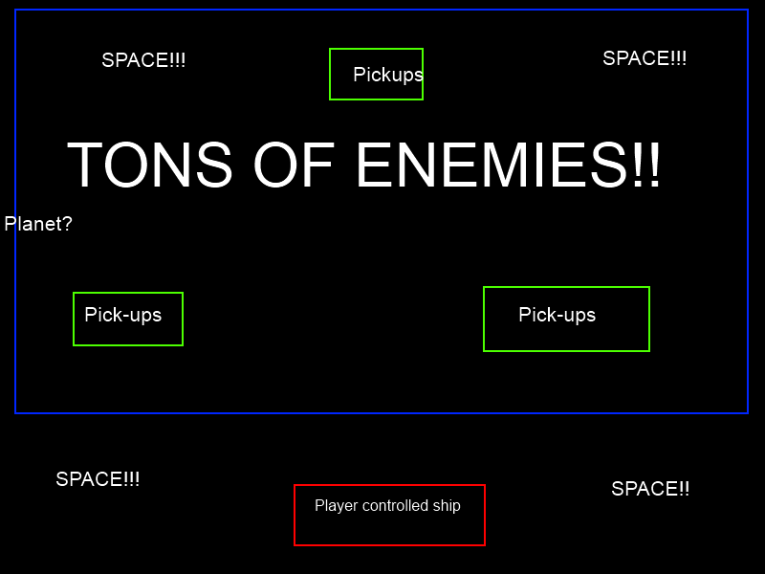Screen Descriptions:

## Intro Screen :

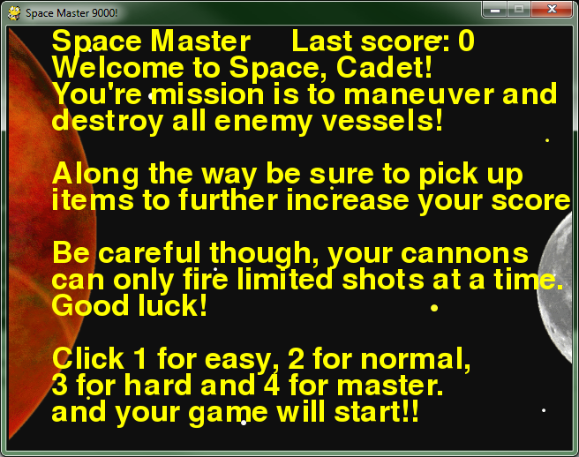

## Game Screen :

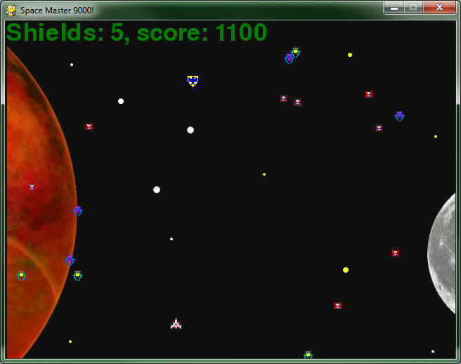

## Gameover Screen:

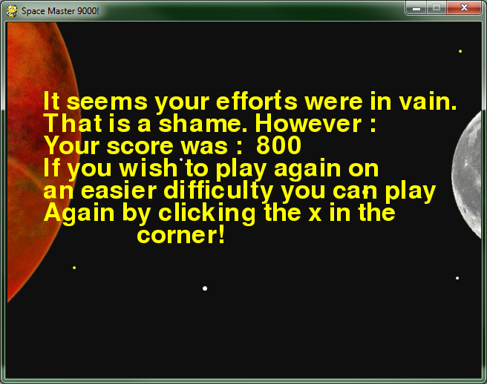

## Easy Difficulty-

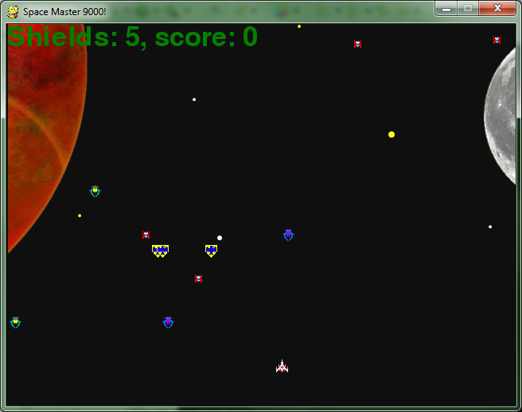

## Normal Difficulty –

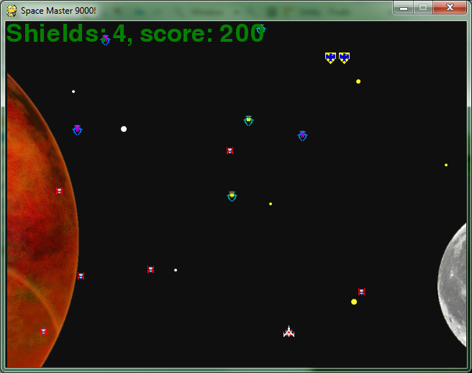

## Hard Difficulty –



## Master Difficulty –

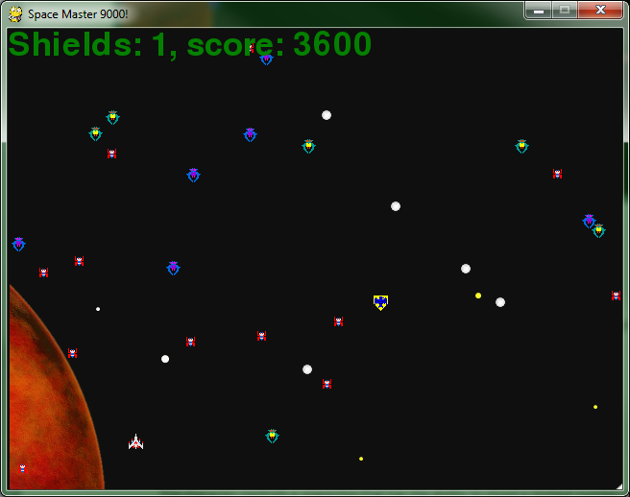

# Game World:

The game is based in space very far from the Earth, Maybe if you play long enough you may make it back to Earth?

# Levels:

There is sadly only one level to my game as of right now.

# Character / Vehicles:

The character controls a spaceship that has the ability to shoot a limited number of projectiles at a time before restarting

# Enemies:

The enemies are generated from a pool of 4 alien classes that each have their own stats ( movement speed ) and image.

# Weapons:

The main weapon of your spaceship is a energon cannon. Although the gun is powerful enough to wipe any enemy out in one hit, it has a drawback that it can only fire limited ammunition at a time. You may want to get the scientists back at home to work on this. I mean if it could fire sprays of ammo what fun would that be.

# Scoring:

Every time the player kills an enemy he gains 200 points. On easy difficulty there are three pickups that give score each giving 100 points. On normal there is two pickups that give 200 point each. On hard there is only one award that gives 400 points. On master difficulty there’s is one award you can pick up that awards 600 points.

# Sound index:

All my sounds came from the website <http://www.freesfx.co.uk/soundeffects> with the exception of my background music which was taken from a Youtube video (<http://www.youtube.com/watch?v=y_OSjjNlO0Y>) and the failed to fire sound which I recorded myself..

# Art / Multimedia Index:

The images used for my sprites came from either Google.com image search or from <http://spriters-resource.com/>. My background was custom made by me.